

CSE470: SOFTWARE ENGINEERING

Software Requirements Specification Document

Project Title: E-tailing

|  |  |
| --- | --- |
| **CSE470 Theory Section: 04, Summer 2023** | |
| **ID** | **Name** |
| 20301473 | Fardin Zaman |
| 19201015 | Fatiha Ishrar Chowdhury |
| 20101365 | Ankhi Akter Mim |
| 19301217 | Hasibul Hossain Shanto |

**Table of Contents**

|  |  |  |
| --- | --- | --- |
| **Section** | **Content** | **Page No** |
| **No** |  |  |
|  |  |  |
| 1 | Introduction | 2 |
|  |  |  |
| 2 | Functional and Non-Functional Requirements | 3 & 4 |
|  |  |  |
| 3 | User Manual | 5 |
|  |  |  |
| 4 | Frontend Development | 13 |
|  |  |  |
| 5 | Backend Development | 22 |
|  |  |  |
| 6 | Technology (Framework, Languages) | 27 |
|  |  |  |
| 7 | Github Repo Link | 28 |
|  |  |  |
| 8 | Individual Contribution | 28 |
|  |  |  |

**Introduction**

Welcome to E-Tailing: Your Ultimate Destination for Stylish and Functional Furniture!

At E-Tailing, we believe that your home is a reflection of your unique style and personality. Our e-commerce platform is dedicated to providing you with a curated collection of furniture that combines aesthetics, comfort, and quality. Whether you're furnishing a cozy apartment, a spacious house, or an office space, we have the perfect pieces to transform your space into a haven of beauty and functionality. With a passion for design and a commitment to exceptional customer service, E-Tailing brings you a seamless online shopping experience. Explore our extensive range of furniture that encompasses a variety of styles, from contemporary to classic, rustic to modern, and everything in between. Our user-friendly website allows you to browse through our catalog with ease, finding inspiration and discovering pieces that resonate with your vision.

What sets E-Tailing apart is not just our diverse selection but also our attention to detail. We understand that furniture isn't just about appearance; it's about enhancing your everyday life. That's why we carefully curate each product, ensuring it meets our high standards for craftsmanship and durability. Whether you're seeking a statement sofa, a functional dining set, or storage solutions that blend seamlessly with your decor, E-Tailing has you covered.

# Functional Requirements

**Requirement 1: Account Creation and Authentication**

* + Users should be able to create a new account using their email or social media profiles.
  + The system should provide secure password storage and offer password reset options.
  + Users should be able to log in securely to their accounts.

**Requirement 2: Furniture Listing and Selling**

* + Registered users (sellers) should have the ability to list furniture items for sale.
  + Sellers should be able to provide details like product name, description, price, images, and dimensions.
  + Sellers should be able to manage their listed furniture items, including editing and deleting them.

**Requirement 3: Viewing Last Viewed Furniture**

* + The system should keep track of the furniture items a user has recently viewed.
  + Users should have a "Last Viewed" section to easily access items they've previously looked at.

**Requirement 4: Furniture Categories and Browsing**

* + The website should categorize furniture into various categories (e.g., chairs, tables, sofas) for easy browsing.
  + Users should be able to browse furniture by category, helping them narrow down their preferences.

**Requirement 5: Adding Furniture to Cart**

* + Users should be able to add furniture items to their shopping cart while browsing.
  + The cart should display item details, quantities, and total prices.
  + Users should have the option to adjust quantities and remove items from the cart.

**Requirement 6: Posting Reviews**

* + Registered users should be able to write reviews for furniture items they have purchased or used.
  + Reviews should include a rating and a text-based review.
  + Users should have the ability to edit or delete their reviews.

# Non-Functional Requirements

**Requirement 1:** Database queries should execute efficiently to ensure quick retrieval and display of product information.

**Requirement 2:** Have a well-defined plan for data recovery in case of catastrophic events, ensuring minimal data loss and downtime.

**Requirement 3:** Implement strong and secure user authentication mechanisms to prevent unauthorized access to user accounts and personal information.

**Requirement 4:** Comply with Payment Card Industry Data Security Standard requirements to protect customer payment information.

**Requirement 5:** Design a user-friendly interface with clear navigation menus and a logical structure to help users easily find and purchase products.

**Requirement 6:** The website should load and respond quickly to user interactions. conditions.

# User Manual

* **Homepage of the website**

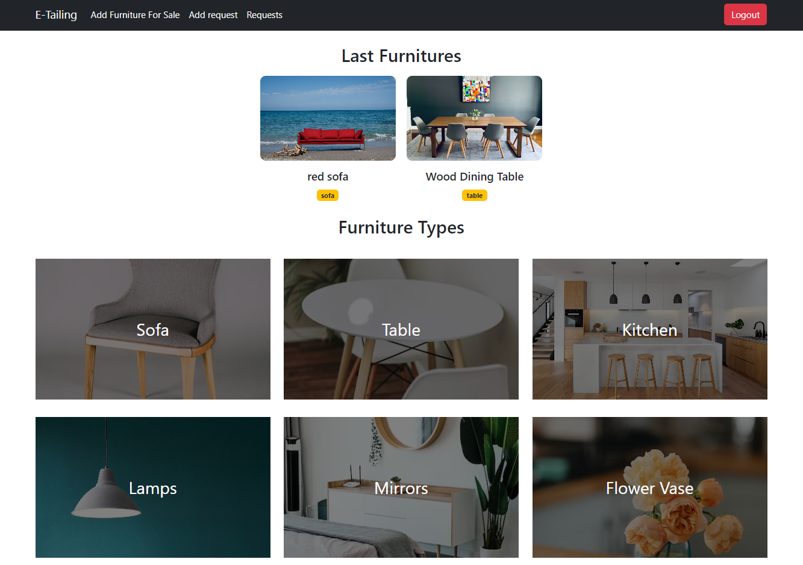

*Fig. Homepage of E-tailing*

Features:

1. Add Furniture: This section invites users to sell their furniture through the platform. Clicking on this button could lead users to a dedicated page where they can list and showcase their furniture items for potential buyers.
2. For Sale: Users can add their furniture for sale in this section.
3. Add Request: This section could be a unique feature that allows users to submit specific furniture requests. Users could input details about the type of furniture they are looking for. This feature helps create a personalized shopping experience by allowing users to express their preferences.
4. Last Viewed Furniture: This section shows thumbnails or images of the furniture items users have recently viewed. It encourages users to revisit items they were interested in and potentially make a purchase.
5. Furniture Type: The home page can have a drop-down or interactive filter that lets users narrow down their search by furniture type. Users can select options like "Chairs", "Tables" etc., and upon selection, they will be directed to a page displaying only items from the chosen furniture type.
6. Review Product: In this section user can write about their product review and post it.

# Login/Registration

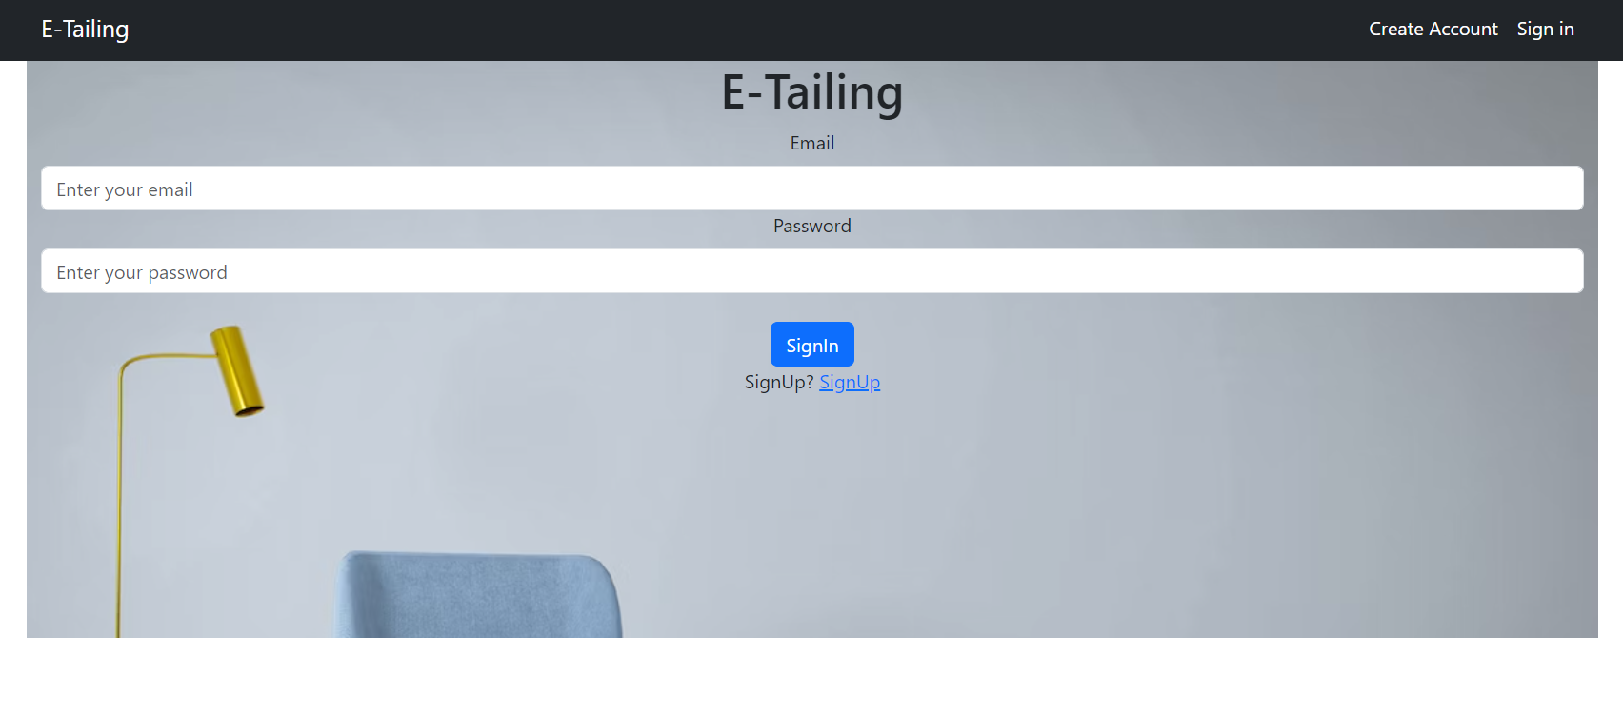

*Fig. User login page in homepage*

Users can create accounts by registering with their email and password, allowing them to access specific features and content. Once registered, users can log in securely using their credentials to access their profiles, saved preferences, and interact with the site's interactive elements.

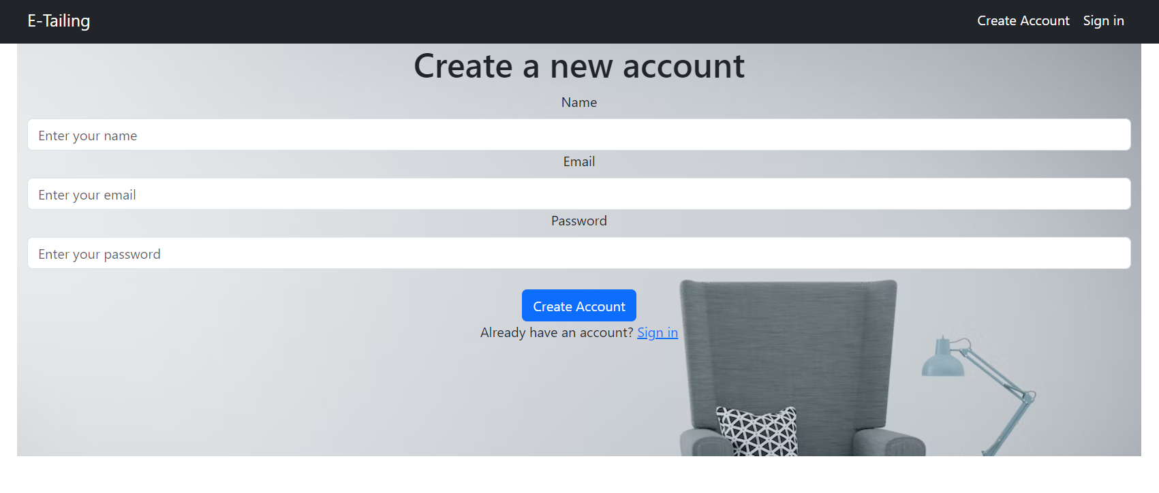

*Fig. User registration page*

# Category Page

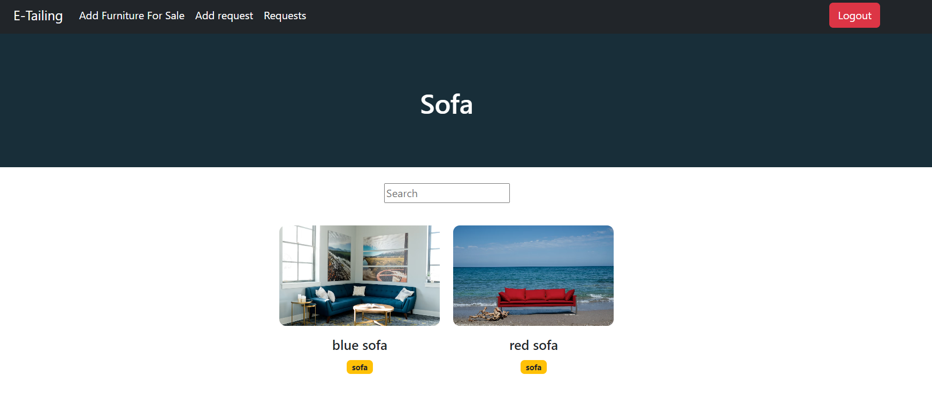

*Fig. category page*

# Request Page

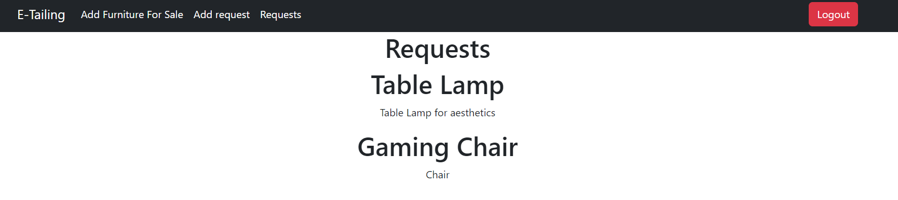

*Fig. Request page*

# Add Request Page

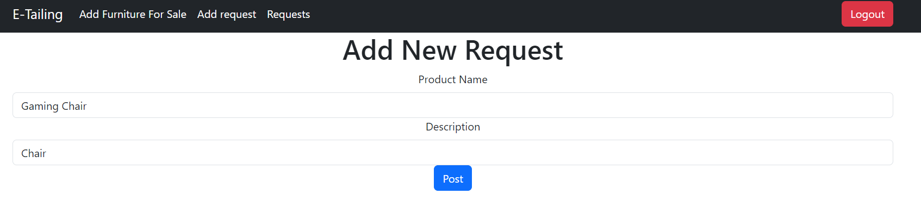

*Fig. Request page*

* Users can request for products by giving the product name and the description.

# Add Furniture

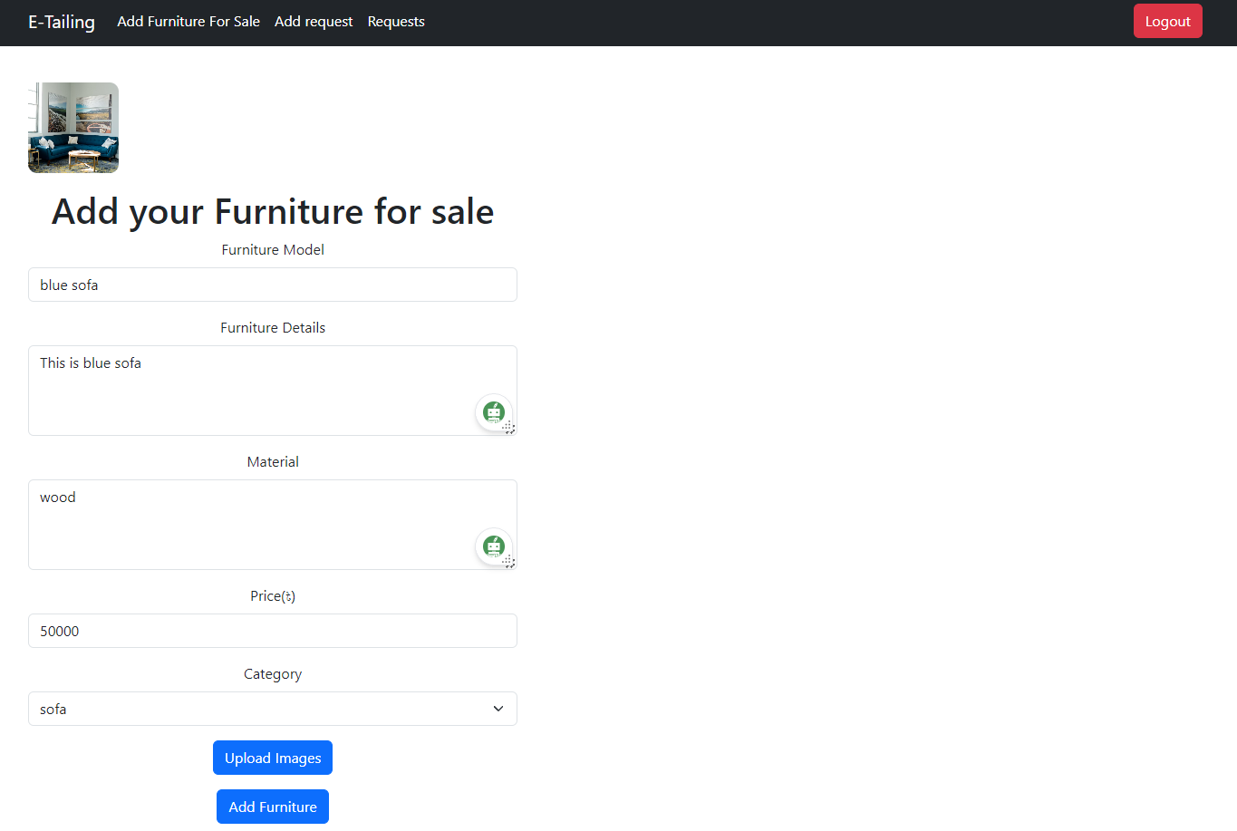

*Fig. Add Furniture page*

# 

# to add furniture, users give furniture model, details, material, price and select the category.

# Product Page

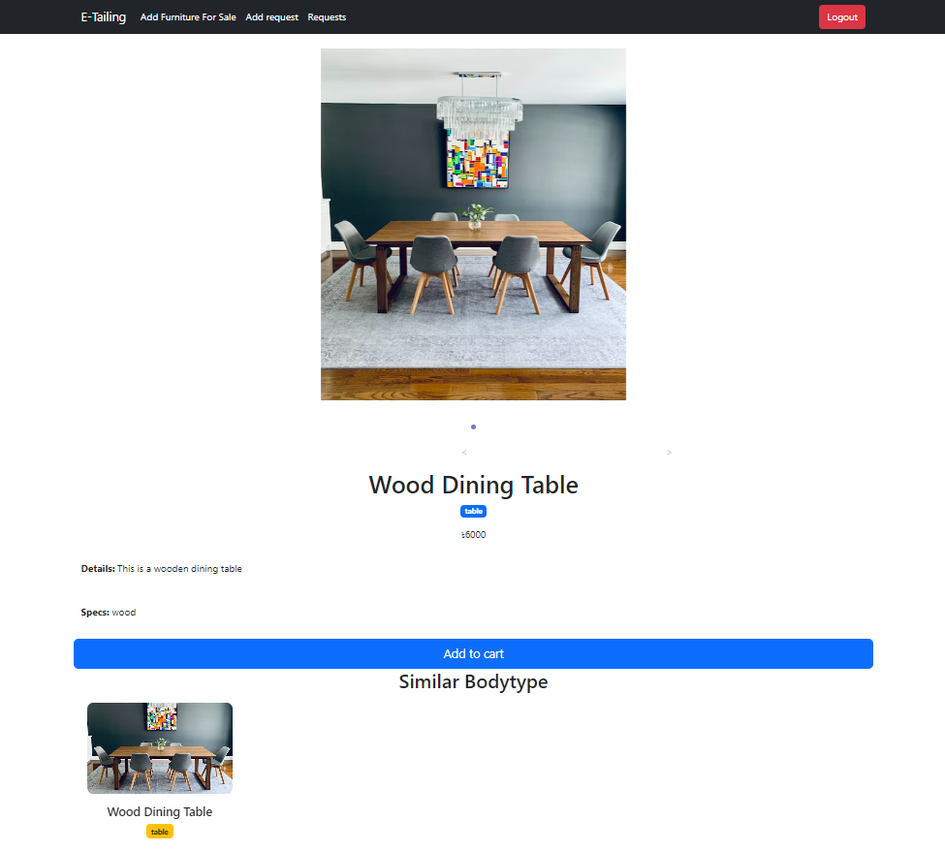

*Fig. product page*

* Product page includes product details, price, pictures and specifics.

# Add To Cart Page

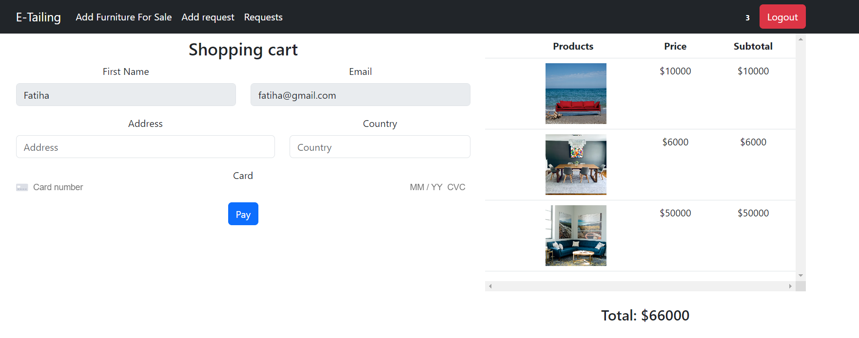

*Fig. add to cart page*

* Cart page displays a summary of the items currently in the user's cart. Each item has an image, name, price, quantity, and a subtotal. It also has the section for user details such as name, address.

# Review

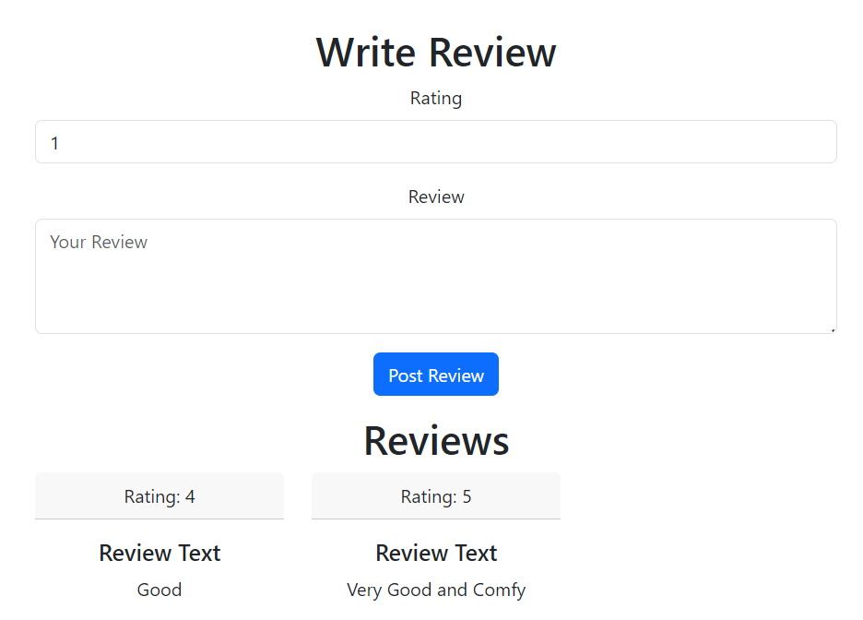

* In this section, users can write about their product review and post it.

# Frontend Development

The front-end development for the project involves creating the user interface and ensuring an engaging and seamless browsing experience for customers. This includes designing responsive web pages, implementing interactive features, and integrating with the back-end to fetch and display furniture products. The front-end is developed using React.js to deliver a visually appealing and user-friendly platform for users to explore and purchase furniture items effortlessly.

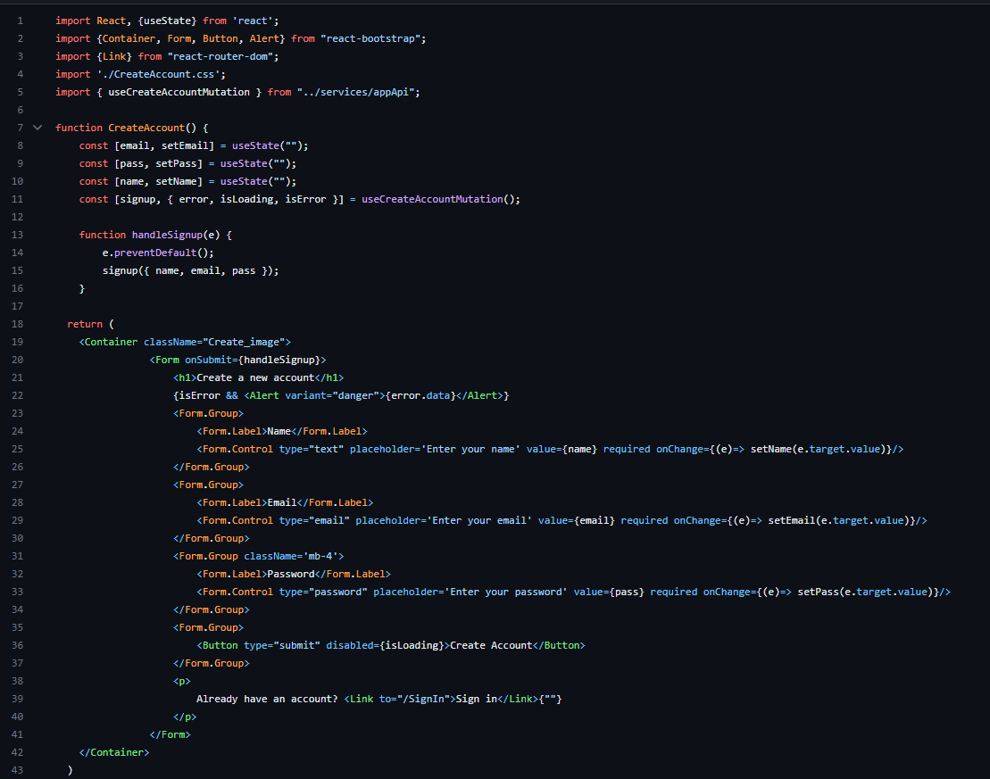

*Fig: Account Creation*

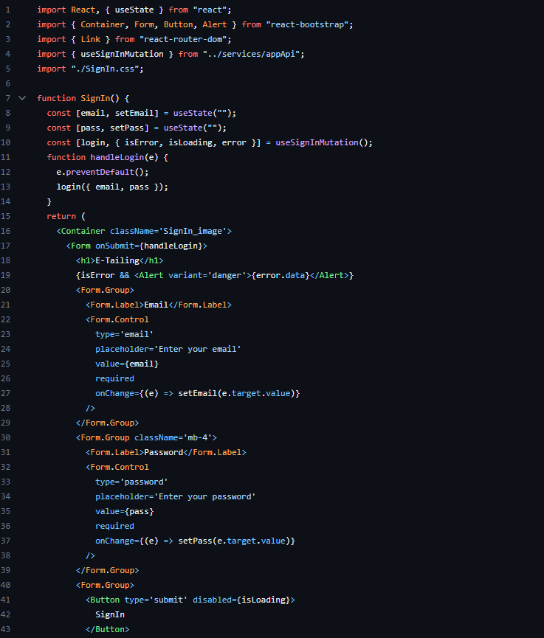

*Fig: Sign In*

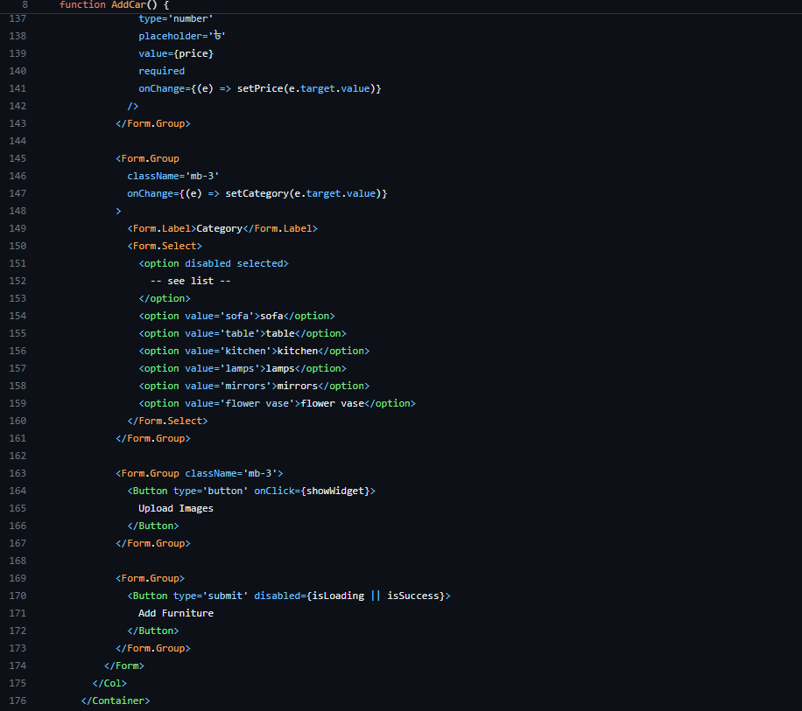

*Fig: Add Furniture for sale*

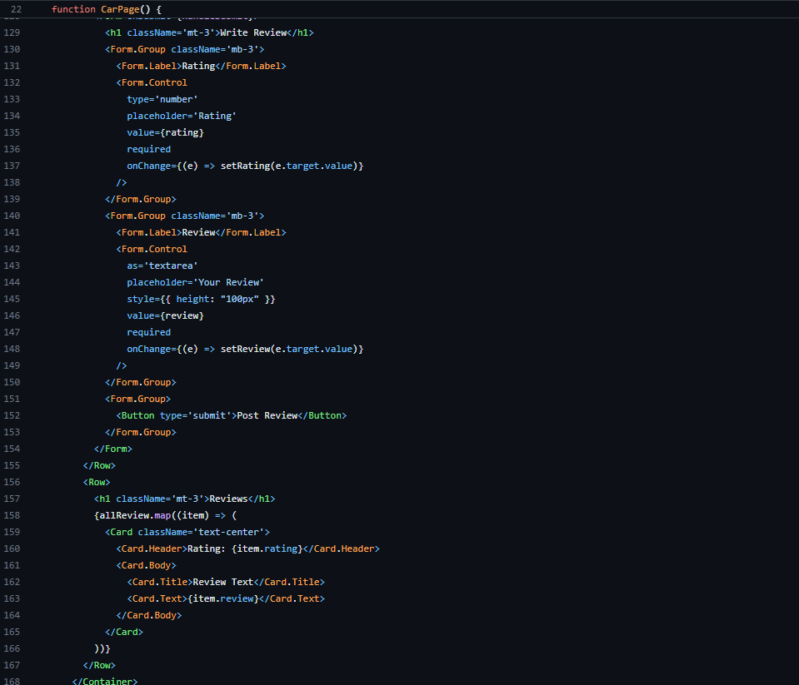

*Fig: Product page and product review*

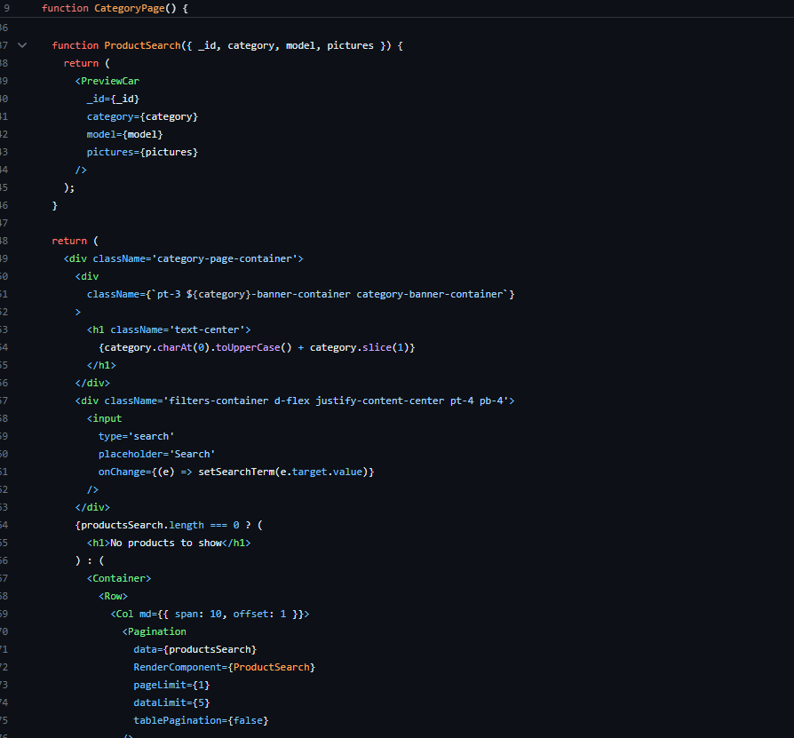

*Fig: Category Page*

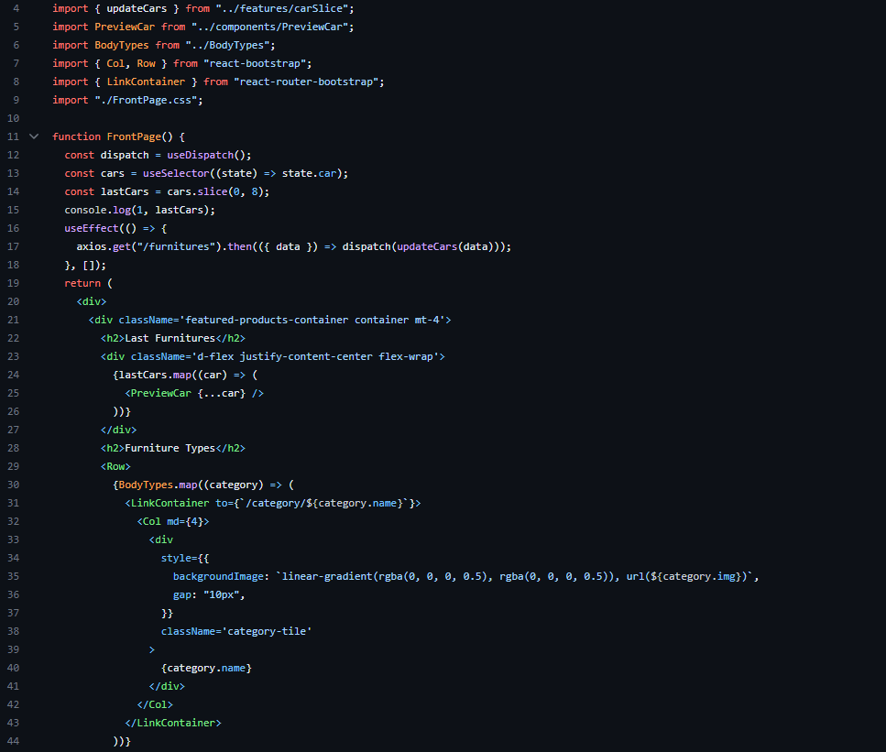

*Fig: Front Page*

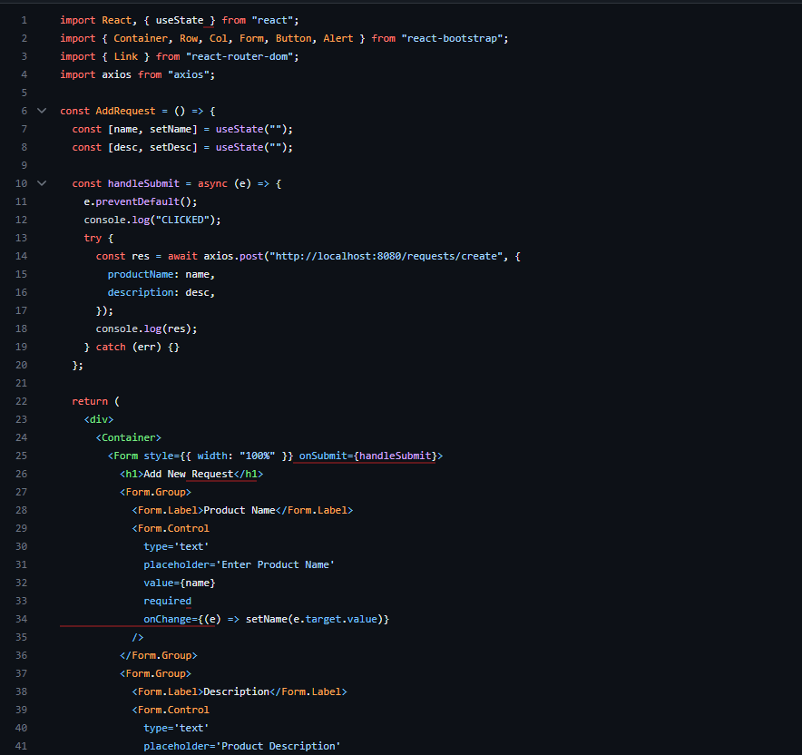

*Fig: Add request*

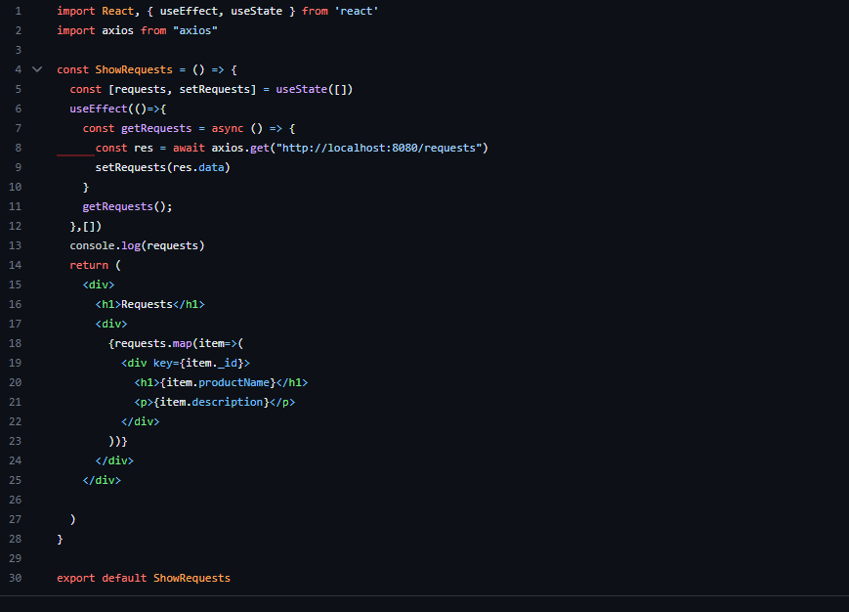

*Fig: Show request*

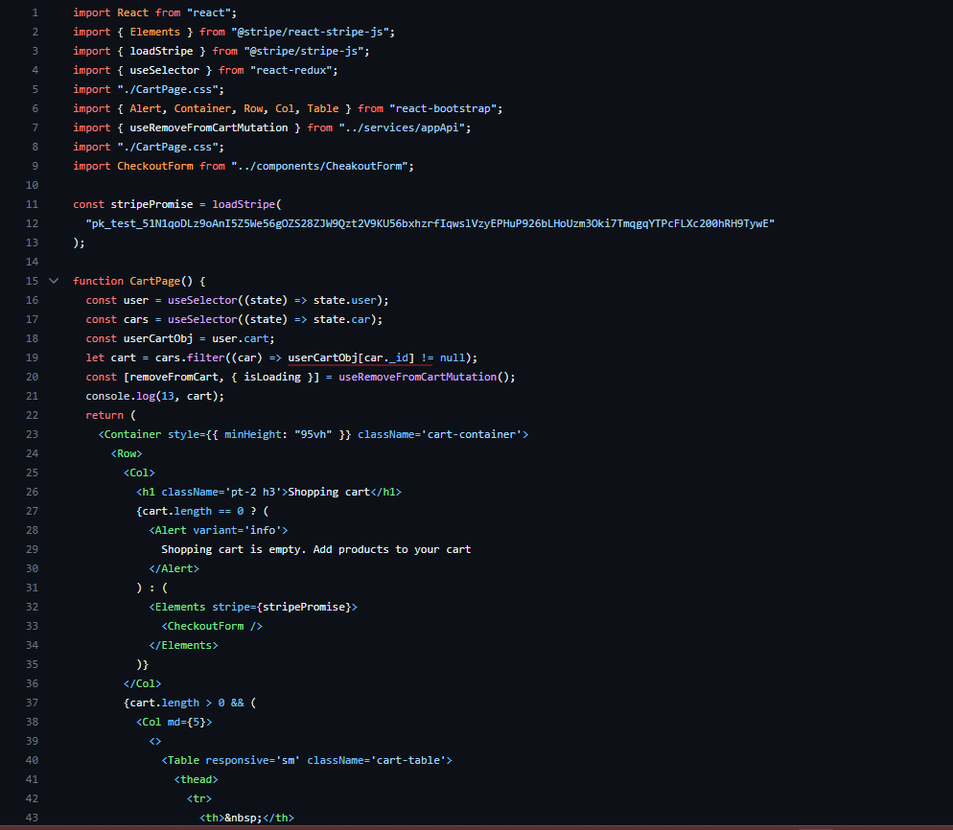

*Fig: Add to Cart*

# Backend Development

The backend development of the project forms the core of the system's functionality. It encompasses the server-side logic and database management necessary to support a seamless shopping experience for users. Node.js and Express.js are used for server-side logic and MongoDB is used for database management. The backend development phase will collaboratively work with the frontend team to ensure seamless integration and deliver a feature-rich, high-performance retailing website for users.

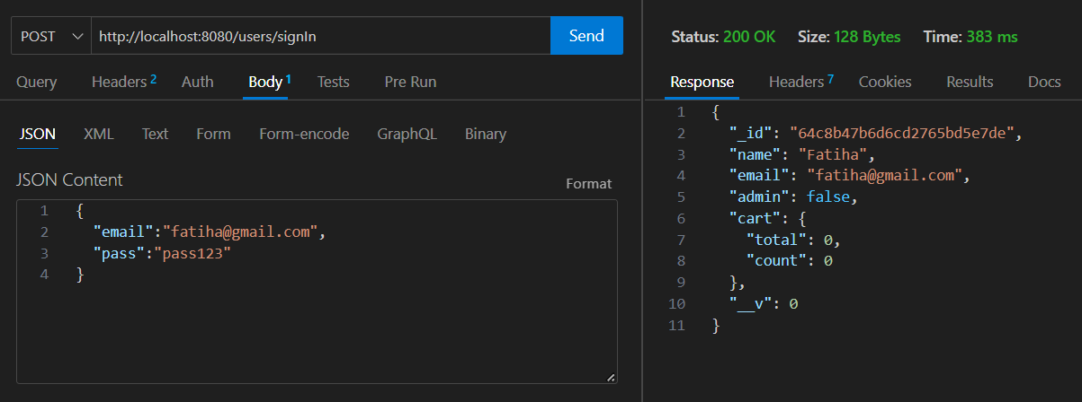

*Fig. Sign In*

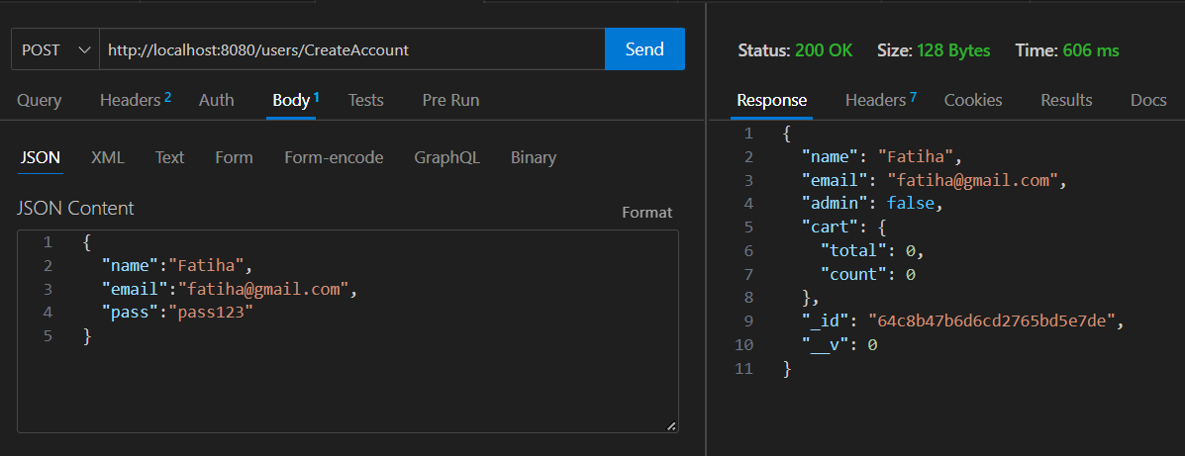

*Fig. Sign Up*

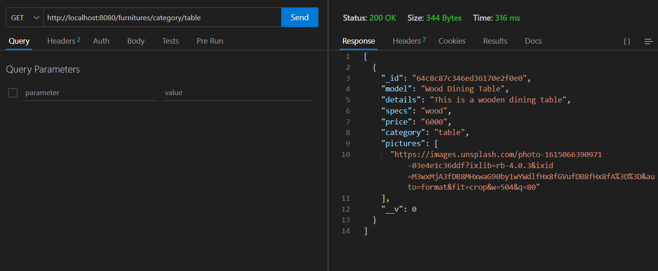

*Fig. Category*

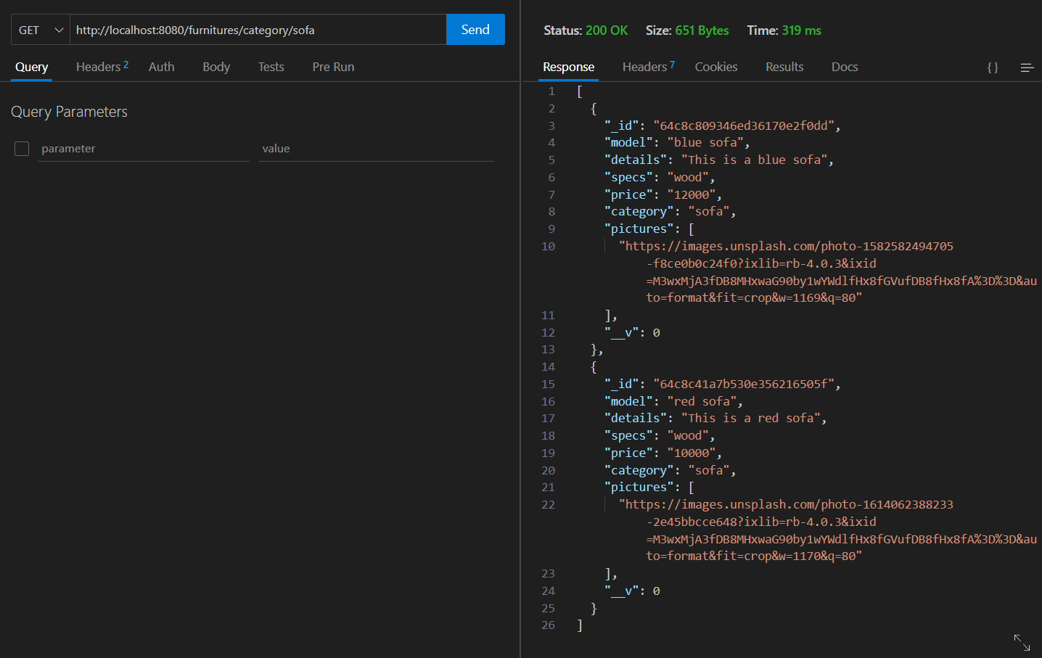

*Fig. Category*

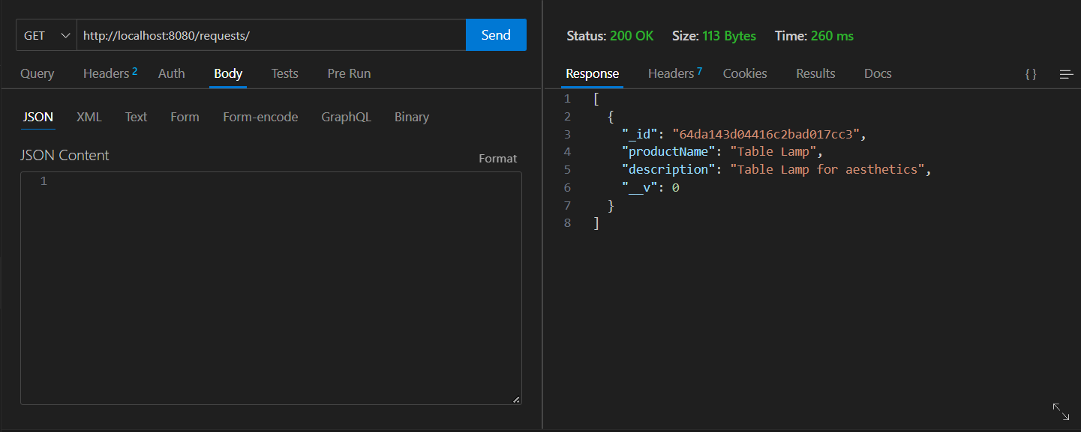

*Fig. Get Req*

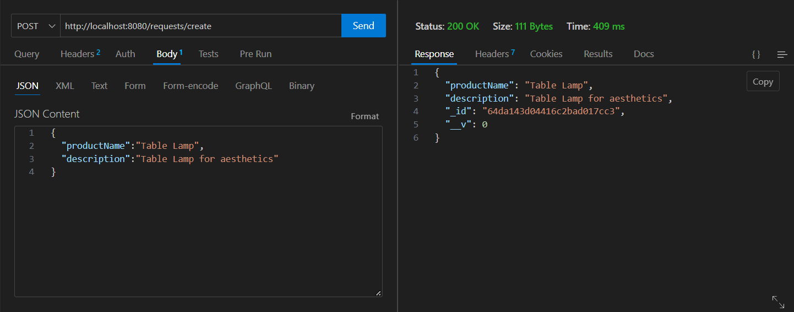

*Fig. Add Req*

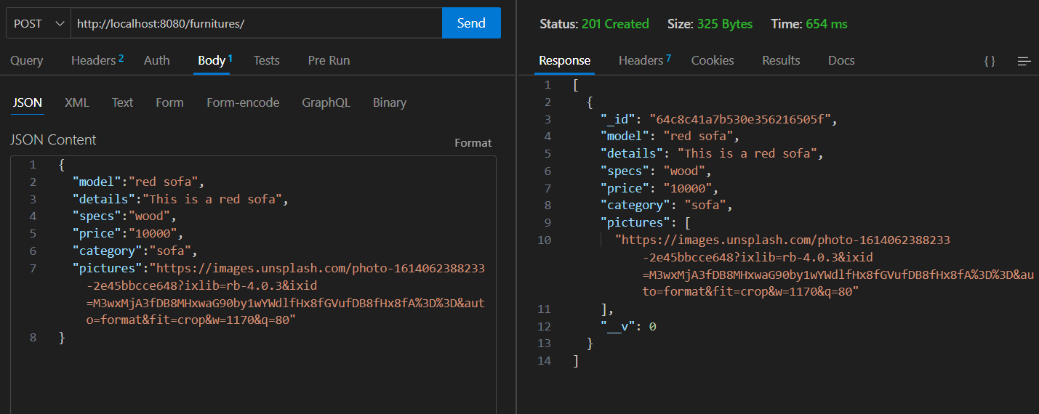

*Fig. Add Furnitures*

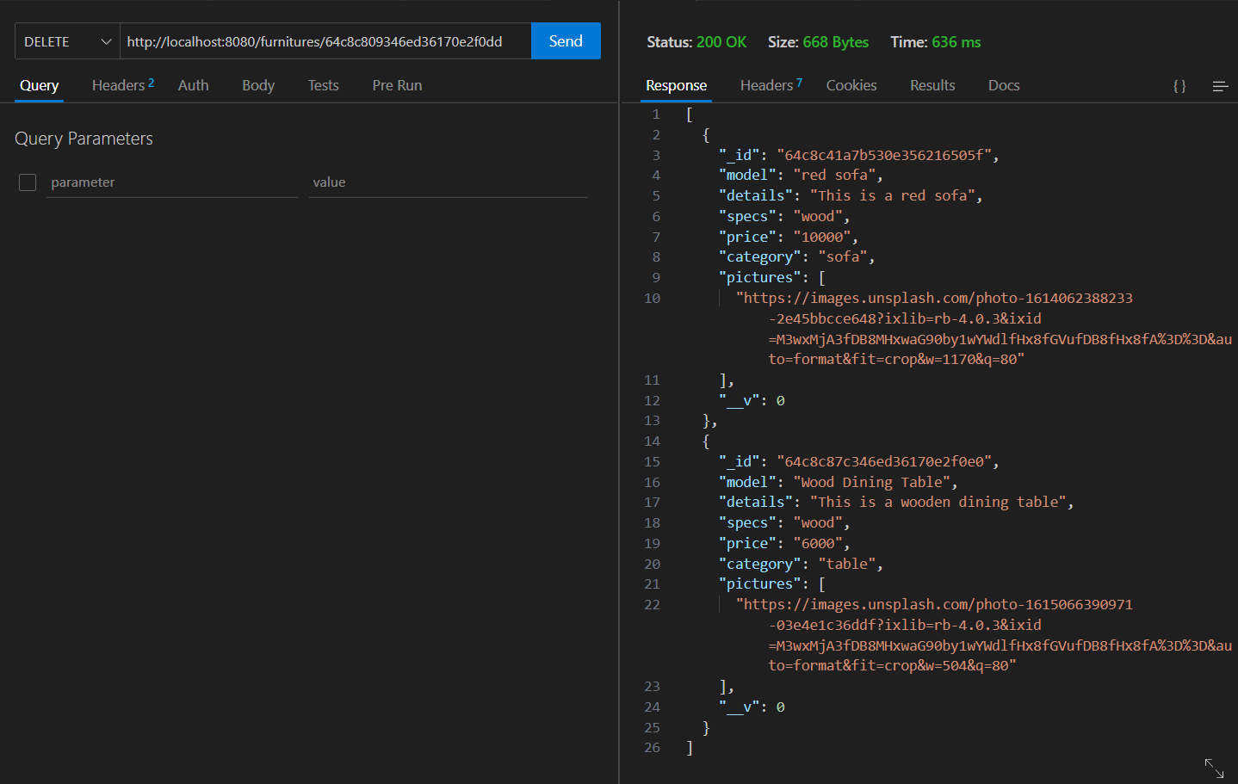

*Fig. Delete Furnitures*

# 

*Fig. Find Furnitures*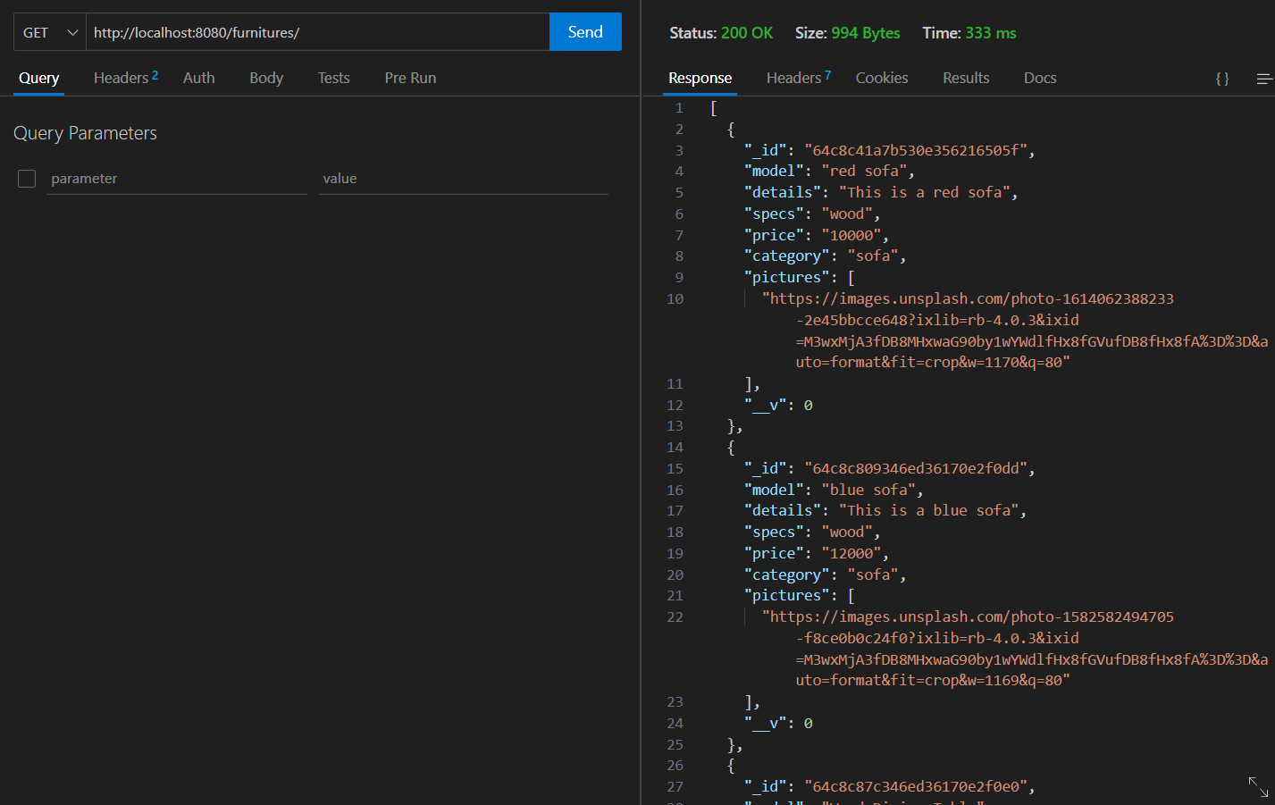

*Fig. Similar Furnitures*

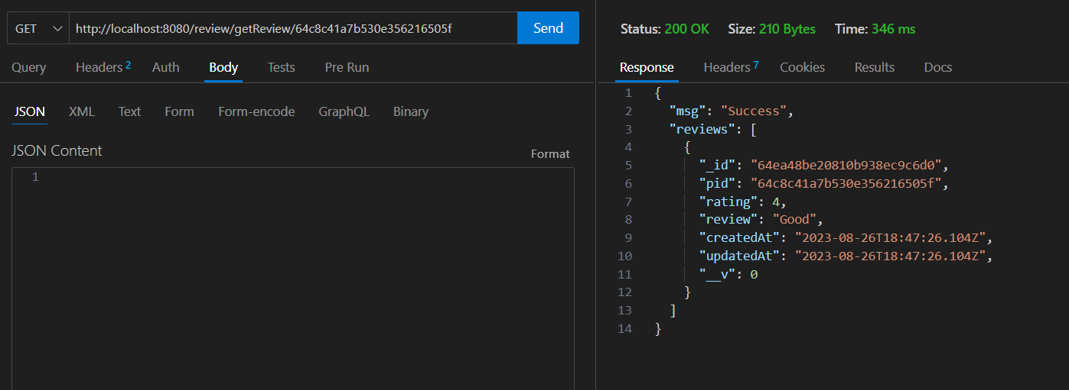

*Fig. Reviews*

# Technology (Framework, Languages)

Framework: React, Node, Express

A strong and well-liked JavaScript library for creating user interfaces is React. It specializes at developing interactive, dynamic, and reusable user interface components. React's component-based architecture and virtual DOM make it effective and ideal for creating complicated user interfaces or single-page applications (SPAs).

JavaScript can run on the server side with the help of the Node.js runtime environment. It offers an event-driven, non-blocking architecture, which makes it suited for creating scalable and fast online applications. The MERN stack's front-end and back-end components may communicate with each other without any interruptions thanks to Node.js.

The back-end web application framework for Node.js is Express.js, which is compact and adaptable. It makes it easier to handle HTTP requests and responses and construct reliable APIs. With its simple design, Express.js gives developers precise control over the organization of the application.

Language: JavaScript

# Github Repository

Link:

https://github.com/Fatiha-Ishrar/E-tailing

# Individual Contribution

|  |  |  |
| --- | --- | --- |
| **ID** | **Name** | **Contribution** |
| 20301473 | Fardin Zaman | Feature 1, Feature 4, Video Demonstration |
| 19201015 | Fatiha Ishrar Chowdhury | Feature 1, Feature 2, Git push and maintain |
| 19301217 | Hasibul Hossain Shanto | Feature 3, Feature 4, SRS Documentation |
| 20101365 | Ankhi Akter Mim | Feature 3, Feature 5, Project Proposal, Requirements Selection |

**Collaborative Efforts**

In the project, our success was rooted in effective collaboration, driven by consistent and open communication among team members. We exchanged updates, challenges, and insights since regular conversations kept us all updated. This active exchange of ideas allowed us to provide fast feedback to each other, creating a dynamic setting where changes and adjustments were made quickly. This seamless communication and rapid feedback loop improved our combined efforts.